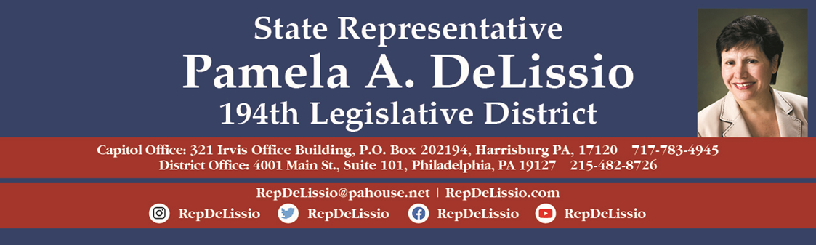

Upcoming Events!

120th Town Hall Meeting Thursday, September 22 @7 p.m.
Topics: Open primaries, money in state politics, and gift ban legislation
Hybrid: Email RepDeLissio@pahouse.net for zoom info
Cathedral Auditorium, Cathedral Village 600E Cathedral Rd.

7th Annual Senior Expo Thursday, September 29 9 a.m. – 12 p.m. Roxborough Memorial Hospital under the white tent on the parking lot off of Rector Street

Free Shred Event Saturday, October 15th 9 a.m. – 11 a.m. Main Street movie theatre parking lot, Manayunk
4 bag/box max enforced.

121st Town Hall Meeting Tuesday, October 18 @ 7 p.m.
Topics: What Needs to Change in Harrisburg
Hybrid: Wolcolf Auditorium, Roxborough Memorial Hospital 5800 Ridge Avenue

194th Book Club Friday, October 21st @ 7 p.m.
How Democracies Die by Steven Levitsky and Daniel Ziblatt.
Read about how elected leaders can gradually subvert the democratic process to increase their power..
Location: District Office, 4001 Main Street Suite 101.
Email RepDeLissio@pahouse.net to sign up. Space is limited.

Free Shred Event Saturday, October 29th 9 a.m. – 11 a.m. Magisterial District Court parking lot, 925 Montgomery Avenue, Narberth
4 bag/box max enforced.

