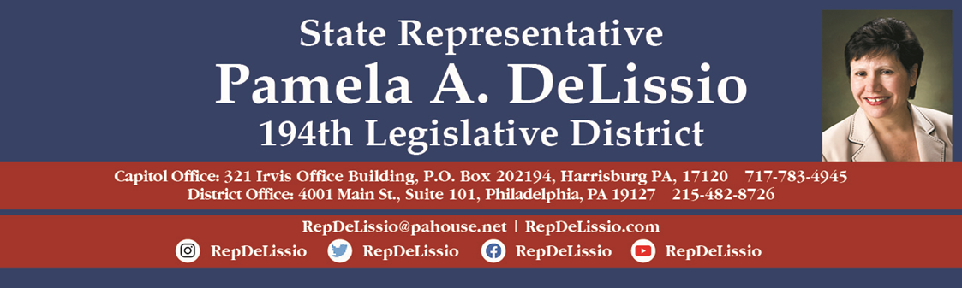
SENIOR EXPO
Thursday, September 29, 2022
9:00 a.m. – 12:00 p.m.
Roxborough Memorial Hospital
5800 Ridge Avenue, Phila., PA 19128
Join us under the tent in the parking lot off Rector Street.

Check out the many exhibitors for:

Lifelong learning & volunteer opportunities
Educational and recreational opportunities
Join your local Civic Association
Furry Friends to Adopt
Renew /apply for your senior SEPTA key ID card
Free health screenings and varied resources

My Senior Expo is during the Good Neighbor Day Health Fair sponsored by Roxborough Memorial Hospital. Call 215-487-4458 to register for your free flu shot.

Plenty of free parking! Septa bus route 9 for public transportation.

