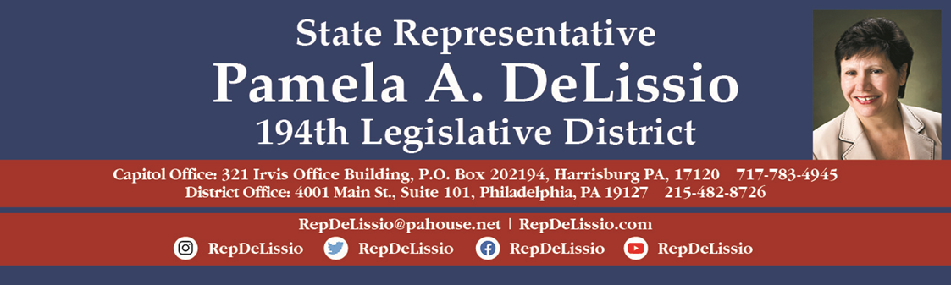
120th Town Hall in-person and virtually
Thursday, Sept 22nd @ 7:00 p.m.
Cathedral Auditorium Cathedral Village
600 E. Cathedral Road, 19128.

Free parking is available in the St Mary’s Church parking lot or along Cathedral Road.
For public transportation, use Bus Route 9 and 27.

Open primaries, the impact of money in state politics, and gift ban legislation

Panelists:
Pat Christmas, Policy Director, Committee of Seventy
Michael Pollack, Executive Director, March on Harrisburg
Sarah Miller, Director of Social Policy, PA League of Women Voters

To participate by Zoom, register by 5 p.m. Wednesday, Sept. 21 by clicking here. After registration, Zoom login information will be sent.
Individuals may also email RepDeLissio@pahouse.net and a registration link will be sent. Once registered, Zoom login information will be sent.
To join on Facebook, visit www.facebook.com/RepDeLissio.
This will be my 28th town hall offered virtually since the COVID-19 pandemic outbreak, and it has proven to be an excellent way to continue to converse and share information with my constituents who prefer or are unable to meet in person.

