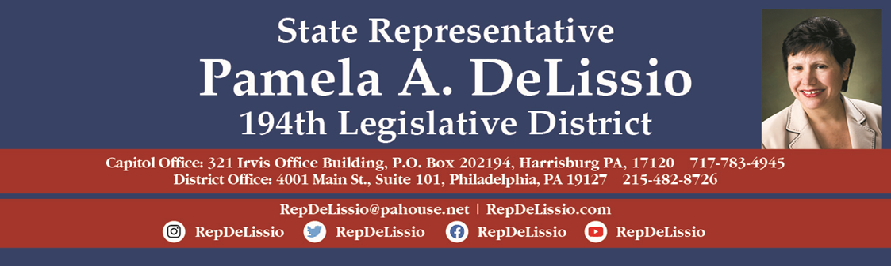
119th Town Hall in-person and virtually
Monday, July 18th @ 10:30 a.m.
Wolcoff Auditorium: Roxborough Memorial Hospital
5800 Ridge Avenue, Phila. 19128
Free parking in the Jamestown Lot or along nearby streets.
For public transportation, use bus route 9.
The critically important state budget and an update on abortion care in Pennsylvania

To participate by Zoom, register by 5 p.m. Friday July 15th by clicking here. After registration, Zoom login information will be sent. Or email RepDeLissio@pahouse.net and a registration link will be sent. Once registered, Zoom login information will be sent.

To join via Facebook, go to /RepDeLissio.
Comments or questions can be posted live or emailed in advance to RepDeLissio@pahouse.net or by leaving a message at 215-482-8726.
The outcome of the decennial redistricting has changed district boundaries of the 194th. New areas of the district will include Ward 38 divisions 11 and 18 in East Falls and Ward 9 divisions 4, 5, 6, 7, 8, 9, 10, 16, 17 of Chestnut Hill. Redistricting officially takes place on December 1, 2022, and in the interim we are happy to include those new constituents now. All are welcome.

