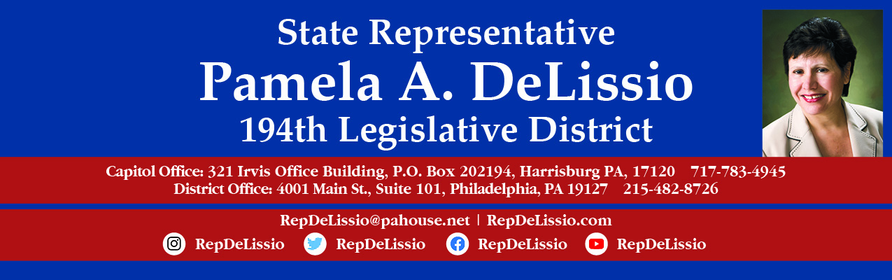

114th Town Hall
Tuesday, February 22nd @ 7:00 p.m.
The state constitutional amendment process
- There have been 70 amendments introduced this legislative session.

- Why these amendments are concerning; how they become law and impact how our sate is governed.

Update on legislative & congressional redistricting

The meeting will be held over Zoom and Facebook Live.

To participate through Zoom, you must register by 3 p.m. February 22nd using this link.
After registration, Zoom login information will be sent.
Or email RepDeLissio@pahouse.net and a registration link will be sent. Once registered, Zoom login information will be sent.
To join via Facebook, go to /RepDeLissio.
Comments or questions can be posted live or emailed in advance to RepDeLissio@pahouse.net or by leaving a message at 215-482-8726.
This is my 22nd Town Hall held virtually since the COVID-19 pandemic outbreak and has proven to be an excellent way to continue to converse and share information with my constituents.

Apply for a mail-in ballot:
Vote.pa.gov

