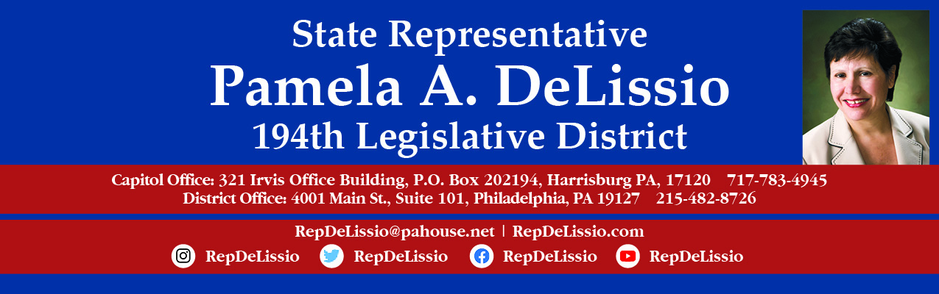

Join me for my 113th Town Hall
Saturday, January 22nd @ 10:00 a.m.
The topic will be Trauma Informed Care
As minority chair of the House Children & Youth Committee, I will host a discussion on Trauma and Covid – 19 and its impact on citizens.

The meeting will be held over Zoom and Facebook Live.

To participate through Zoom, you must register by 4 p.m. January 21st using this link.
After registration, Zoom login information will be sent.
You may also email RepDeLissio@pahouse.net and a registration link will be sent. Once someone is registered, Zoom login information will be sent.
To join us via Facebook, go to /RepDeLissio.

Comments or questions can be posted live or emailed in advance to RepDeLissio@pahouse.net or by leaving a message at 215-482-8726.
This is my 21st Town Hall held virtually since the COVID-19 pandemic outbreak and has proven to be an excellent way to continue to converse and share information with my constituents.

