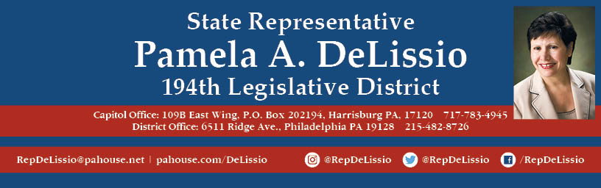

Join me for my 110th Town Hall
Friday, September 17th @ 10:30 a.m.
The topic will be redistricting, with guest speaker Carol Kuniholm, co-founder and chair of Fair Districts PA.
2021 is the year that we redraw legislative district boundaries for state senate and representative offices and Congress. This town hall will provide an important update as to where we are in the process and how you can advocate for non-gerrymandered district.

The meeting will be held over Zoom and Facebook Live.

To participate through Zoom, you must register by 5 p.m. Sept. 16th using this link.
After registration, Zoom login information will be sent.
You may also email RepDeLissio@pahouse.net and a registration link will be sent. Once someone is registered, Zoom login information will be sent.
To join us via Facebook, go to /RepDeLissio.

Comments or questions can be posted live or emailed in advance to RepDeLissio@pahouse.net or by leaving a message at 215-482-8726.
This is my 17th Town Hall held virtually since the COVID-19 pandemic outbreak and has proven to be an excellent to continue to converse and share information with my constituents.

