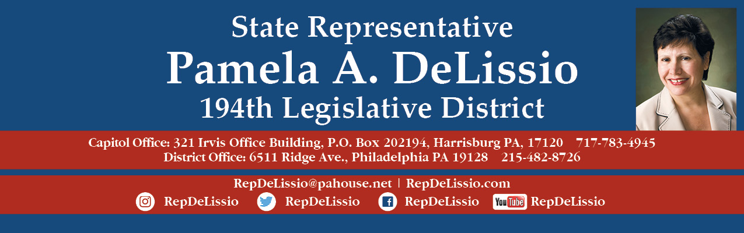

**Free Shred Events for Constituents of the 194th**



**Saturday, May 15th, 2021:  9:00 a.m. to 11:00 a.m.**

**Main Street Movie Theatre Parking Lot**

**3720-40 Main St, Manayunk 19127**

**Sunday, May 23rd , 2021: 9:30 a.m. to 11:30 a.m.**

**Welsh Valley Middle School Parking Lot,**

**325 Tower Ln, Narberth, PA 19072**

**There is a limit of four grocery bags or banker boxes per household, and attendees may be asked to transport their materials from their vehicles to the bins for shredding. Attendees must wear masks and practice social distancing. Newspapers, magazines and journals will not be accepted.**

**The event will end sooner than 11 a.m. / 11:30 accordingly if the truck is full. Shredding is done on-site and all shredded paper will be recycled. These events are rain or shine.**