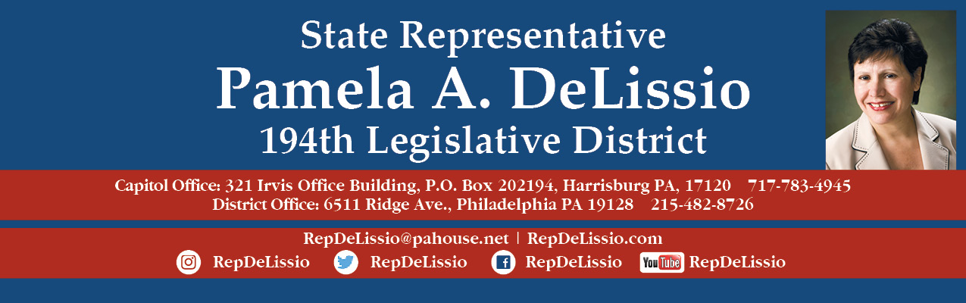

**106th Town Hall via ZOOM and Facebook Live**

**Wednesday, May 26th @ 7:00 p.m.**

**Topics will include the redistricting process to redraw congressional and state legislative district boundaries.**

**This process has been politically manipulated for decades.**

**A vaccine update will also be provided.**

**To participate through Zoom, please register by 2 p.m. Wednesday. May 26th using** [this link](https://us02web.zoom.us/meeting/register/tZAvcOuuqzIjHtfN9IjhzQJL7y522-SE4vIK). **After you register, Zoom login information will be sent.**

**You may also email** [RepDeLissio@pahouse.net](mailto:RepDeLissio@pahouse.net) **of your interest and a registration link will be sent. After you register, Zoom login information will be sent.**

**The Town Hall will also be live streamed on** [facebook.com/RepDeLissio](https://www.facebook.com/RepDeLissio/).

**Comments or questions can also be emailed in advance to**[**RepDeLissio@pahouse.net**](mailto:RepDeLissio@pahouse.net)**, or leave a message at 215-482-8726.**

This is my 14th Town Hall held virtually since the COVID-19 pandemic outbreak and has proven to be an excellent to continue to converse and share information with my constituents.