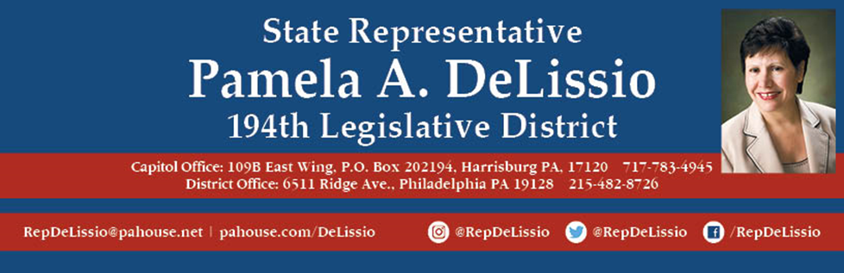

**FREE Shred Event**

**Saturday, October 24th, 9:00 to 11:00 a.m.**

**Main Street Movie Theatre Parking Lot**

**3720 Main St, Manayunk**

**( new location )**

**Attendees must wear masks and practice social distancing.**

**Attendees must be prepared to handle their own materials from vehicle to bins for shredding.**

**4 grocery bag / banker box per household maximum.**

**No newspapers, magazines, or journals will be accepted.**

**Shredding ends at 11 sharp or before if truck is full.**

**All Shred events are rain or shine.**