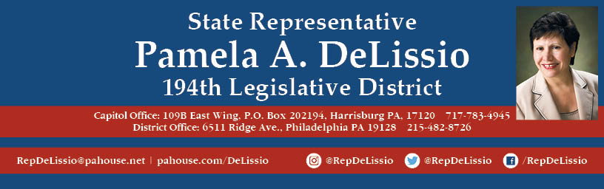

**Join my 96th Town Hall via Facebook LIVE!**

**Thursday, June 18th @ 7:00 P.M.**

**The discussion will center on the current happenings in the Pennsylvania’s House.**

**Each of us has had to adjust quickly to navigate our everyday lives in the midst of a worldwide pandemic.**

**In the state legislature, that has meant ongoing debates about the process of reopening our commonwealth, the recent passing of a stop gap budget, legislation for police reform, and the attempts of the legislature to terminate the Governor’s disaster declaration order. I will cover these topics.**

**Participate in this Facebook Live event by joining me at**

**/RepDeLissio.**

**Comments or questions can be posted live in the comment stream, or email in advance to**[**RepDeLissio@pahouse.net**](mailto:RepDeLissio@pahouse.net)**, or leave a message at 215-482-8726.**