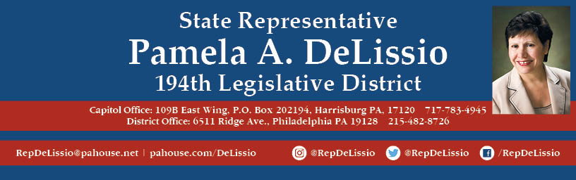

**Join me for my 87th Town Hall**

**Interested in understanding different viewpoints on Article V of the U.S. Constitution?**

I will review two resolutions being presented to the PA House that support amending the U.S. Constitution.

**Join us on hearing speakers from:**

* [PA United to Amend](https://paunitedtoamend.wordpress.com/)
* The [Convention of States Project](https://conventionofstates.com/)
* [Common Cause Pennsylvania](https://www.commoncause.org/pennsylvania/)

Whether you are in favor or oppose the goals of these resolutions, I look forward to having this dialogue.

**Thursday, August 22nd@ 7p.m.**

[**Roxborough YMCA**](https://philaymca.org/locations/roxborough/)

**7201 Ridge Ave., Philadelphia**

**Plenty of free parking. Bus routes 9, 65, or 62.**