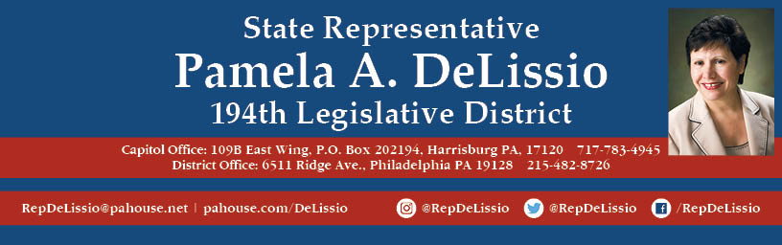

**Join me for my 86th Town Hall**

**Our topic: $34 billion of citizen’s money that support the recently passed 2019-2020 budget**

**The Spending Plan and the code bills.**

**And the process!!!!**

**Thursday, July 18th @ 7 p.m.**

**Roxborough Church**

**8230 Ridge Ave, Philadelphia, 19128**

**Plenty of free parking**

**Bus route 9 and 27**