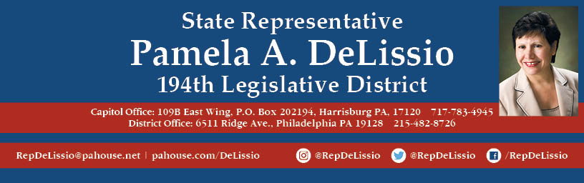

**Join me for my 84th Town Hall**

**The Future of Nuclear Energy**

The implications of reopening the Alternative Energy Portfolio Standards Act of 2004 and the debate on the state policy effort to address the needs of the nuclear energy industry will be discussed.

**Wednesday, May 22nd, 2019 @ 7 p.m.**

**Wolcoff Auditorium, Roxborough Memorial Hospital**

**5800 Ridge Avenue, Phila**

           Plenty of free parking in the Jamestown Lot

Bus Route 9