

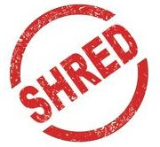 

**Free Upcoming Shred Events**

**Saturday, April 13th, 2019 – 9:00 to 11:00 a.m.**

**Magisterial District Court Parking Lot**

**925 Montgomery Avenue, Narberth, PA 19072**

**Saturday, May 11th, 2019 – 9:00 to 11:00 a.m.**

**Roxborough Municipal Parking Lot**

**514 Dupont Street, Philadelphia, PA 19128**

**All shredding occurs on site.**

**Rain or shine!**

**4 banker box or grocery bag maximum**