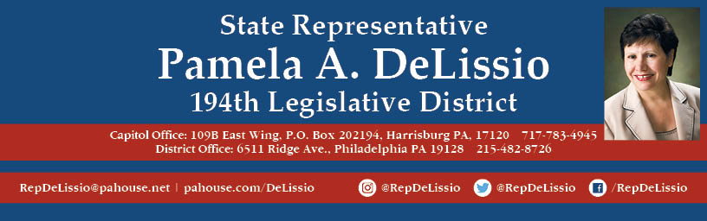

**Join us for my 83rd Town Hall**

**Two special guests will speak on electing the President via the current Electoral College system versus the National Popular Vote**

* Attendees will better understand the pros and cons of each method.

**Tuesday, April 23rd @ 10:30 a.m.**

**Belmont Hills Library**

**120 Mary Watersford Rd**

**Bala Cynwyd, PA 19004**

           Plenty of free parking